## horizontal line



Sales Analytics

**Report**

**Date : 11.09.2023**

**─**

Srikrishnan Shankar

Personal Project

# Table of Contents:

1. Introduction
2. Abstract of the Project
3. Tools/Softwares Used
4. Data Preprocessing: (Data Cleaning)
5. Exploratory Data Analysis: (EDA - KPI Metrics Derivation)
6. Final Dashboard: U.S. Superstore Sales Analysis
7. Conclusion

# 

# 1) Introduction:

* The ‘**Superstore Sales**’ dataset is a comprehensive and versatile collection of data.
* Provides insights into sales, customer behavior, and product performance.
* Valuable resources for in-depth analysis.
* Containing information from diverse regions and segments, the dataset enables exploration of trends, patterns, and correlations in **sales and customer preferences**.
* The dataset encompasses sales transactions, enabling researchers and analysts to understand buying patterns, identify high-demand products, and assess the effectiveness of different shipping modes.
* Moreover, the dataset provides an opportunity to examine the impact of various factors such as **discounts, geographical locations, and product categories on profitability**.
* By analyzing this dataset, businesses and data enthusiasts can uncover actionable insights for optimizing **pricing strategies, supply chain management, and customer engagement**.

# 2) Abstract: Goals

1. To Perform **Data Pre-Processing** to clean the data for the **Analysis**.
2. To Perform **Exploratory Data Analysis** and derive **Key Performance Metrics** that is needed for the **Business Decisions**.
3. To Build an **Interactive Dashboard** to **Analyze** the **Trend** of the **data** with **Graphical Visuals**.

# 3) Softwares Used:

The Software tool used for this Analytics Project is **Microsoft Excel**.

## **Microsoft Excel**

* Microsoft Excel is a spreadsheet editor developed by Microsoft for Windows, MacOs, Android and iOs devices.
* It features calculation or computation capabilities, graphical tools, pivot tables and macro programming language called Visual Basic for Applications.
* Excel forms part of the Microsoft 365 suite software.

# 4) Data Preprocessing: Data Cleaning

**Data Preprocessing** is a method of **cleaning data** before **Analyzing** to make sure that we are not displaying **irrelevant information** from the **data.**

# Issue: Negative Values

* The Issue that we have with our **data** is **Negative Values** in the **Profit Column** which consist of **1871 Negative Values**.
* **DAX Function** is used to identify the number of **Negative Values** in the Dataset, Image is attached below for the **reference**.

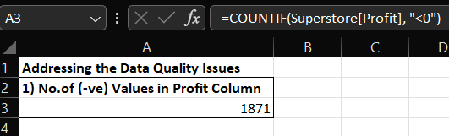

# 5) Exploratory Data Analysis: Key Performance Indicator (KPI)

**Exploratory Data Analysis** is a method of **Initial Investigation** on the given **Dataset**.

# Key Metrics Derived:

The **KPI Metrics** to be delivered are:

1) **Total Sales**

2) **Total Profit**

3) **Profit Margin**

4) **Average Discount**

5) **Total Customers**

6) **Total Orders**

7) **Average Order Value**

8) **Sales by State (Top 10)**

9) **Sales by Sub-Category**

10) **Sales vs Profit by Shipmode**

11) **Sales vs Profit by Quarter, Month**

12) **Top 10 Customers by Sales**

13) **Top Selling Products by Quantity Sold**

1. **INTERACTIVE FILTERS:**

* **Interactive Filters** are created to make the **Dashboard** work **Dynamically** for the **Analysis.**

1. **Filter 1 : YEAR (2011, 2012, 2013, 2014)**

This Filter is used to **analyze** the **metrics** on the basis of the **Year**.

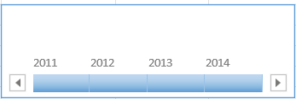

1. **Filter 2 : REGIONS (West, South, East, Central)**

This Filter is used to **analyze** the **metrics** on the basis of **Region**.



1. **Filter 3 : PRODUCT CATEGORIES (Technology, Office Supply, Furniture)**

This Filter is used to **analyze** the **metrics** based on **Product Categories**.



1. **METRIC 1: TOTAL SALES / REVENUE**

* **Total Sales:** Sum of all sales transactions. This KPI provides an overall view of the revenue generated
* The **Total Sales** (or) **Total Revenue** is **$22,10,401.98**.
* Below Image is attached for the **DAX Function Caculation**.

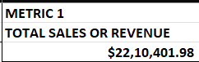

**CALCULATION:**



**CARD:**

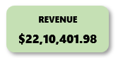

1. **METRIC 2: TOTAL PROFIT**

* **Total Profit:** Sum of profits from all transactions. This helps assess the overall profitability.
* The **Total Profit** is **$3,13,506.95**.
* Below Image is attached for the **DAX Function Caculation**.

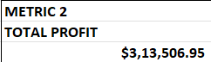

**CALCULATION:**



**CARD:**

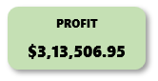

1. **METRIC 3: PROFIT MARGIN**

* **Profit Margin:** (Total Profit / Total Sales) * 100. This KPI represents the percentage of profit relative to sales.
* The **Profit Margin** is **14.18**.
* Below Image is attached for the **DAX Function Calculation.**

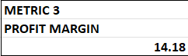

**CALCULATION:**



**CARD:**

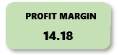

1. **METRIC 4: AVERAGE DISCOUNT**

* **Customer Count:** Count of unique Customer IDs. This tells you the number of unique customers.
* The **Average Discount** is **14.69**

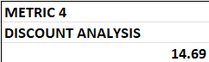

**CALCULATION:**



**CARD:**

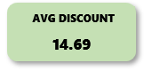

1. **METRIC 5: TOTAL CUSTOMER**

* Count of Unique **Customer ID**s. This tells you the number of **Unique Customers**.
* The **Total Customers** is **793**.

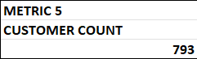

**CALCULATION:**



**CARD:**

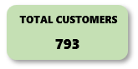

1. **METRIC 6: TOTAL ORDERS**

* Count of unique **Order ID**s. It shows how many orders were placed.
* **Total Orders** is **4941**.

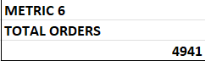

**CALCULATION:**



**CARD:**

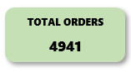

1. **METRIC 7: AVERAGE ORDER VALUE (AOV)**

* Total Sales divided by the Number of Orders(**Unique**). **AOV** indicates the average amount customers spend per order.
* The **Average Order Value (AOV)**  is **$447.36**.

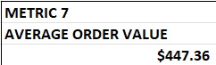

**CALCULATION: REVENUE / TOTAL ORDER**



**CARD:**

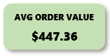

1. **METRIC 8: SALES BY STATE (TOP 10)**

* **Sales by State (Top 10):** This generates which state are contributing the most to your overall sales.
* The most **Sales** generated **State** is **California**, which has generated sales amount of **$4,52,371.03**.

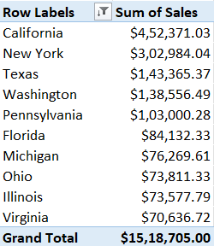

**CHART :**

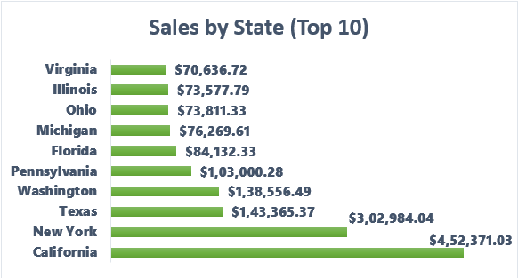

1. **METRIC 9: SALES BY SUB-CATEGORY**

* **Sales by Sub-Category:** The sum of Sales grouped by Product Sub-Category. THis shows which Product subcategories are the most profitable.
* The most **Sales** generated **Product Sub-Category** is **Phones**, which has generated an amount of **$3,26,849.11**.

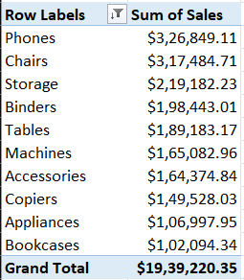

**CHART :**

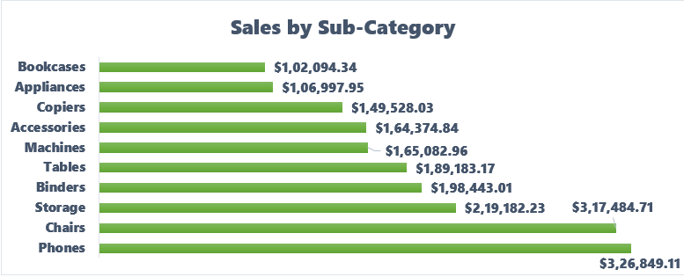

1. **METRIC 10: SALES vs PROFIT by SHIPMODE**

* **Sales vs Profit by Shipmode:** This shows overall characteristics of sales by Shipmode.
* The Shipmode of **Standard Class** has generated huge **Sales** amount of **$13,04,352.50**.

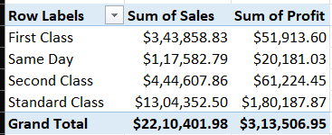

**CHART :**

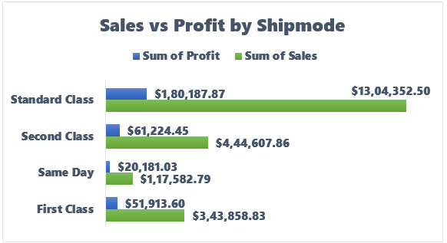

1. **METRIC 11: SALES vs PROFIT by MONTH/QUARTER**

* **Sales vs Profit by Month / Quarter / Year:** This actually generates trend of Sales by Month
* The Overall Performance of **Sales** and **Profit** has grew in the month of **December**  or **Quarter 4**.

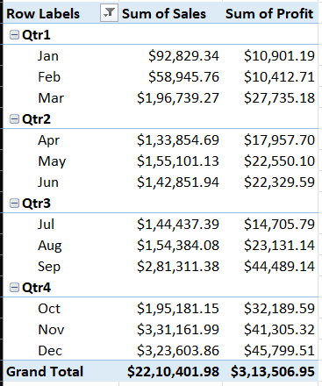

**CHART :**

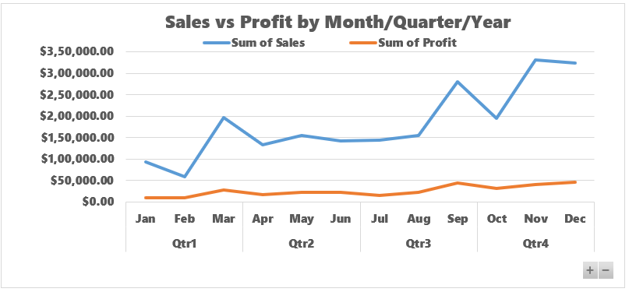

1. **METRIC 12: TOP 10 CUSTOMERS by SALES**

* **Top Customers by Sale:** Lists out Top 10 customers who have generated maximum Sales.
* **Sean Miller** is our **Top Customer**, who has generated **Sales** amount of **$25,043.05**.

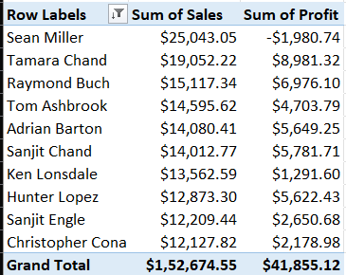

**CHART ;**

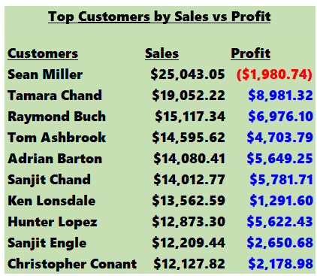

1. **METRIC 13: TOP PRODUCTS by QUANTITY SOLD**

* **Top Products by Quantity Sold:** Lists out Top 10 Product Names which was sold at highest quantity vs generated Sales.
* **Staples** is the **Best Product**, which has sold out in **Quantity** of **867**.

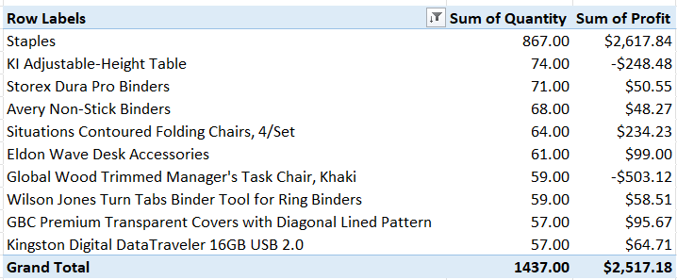

**CHART :**

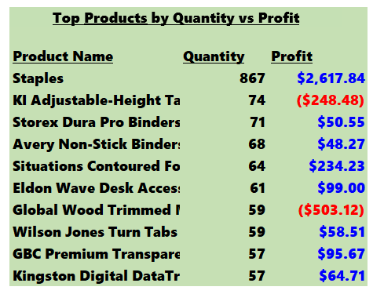

# Final Dashboard:

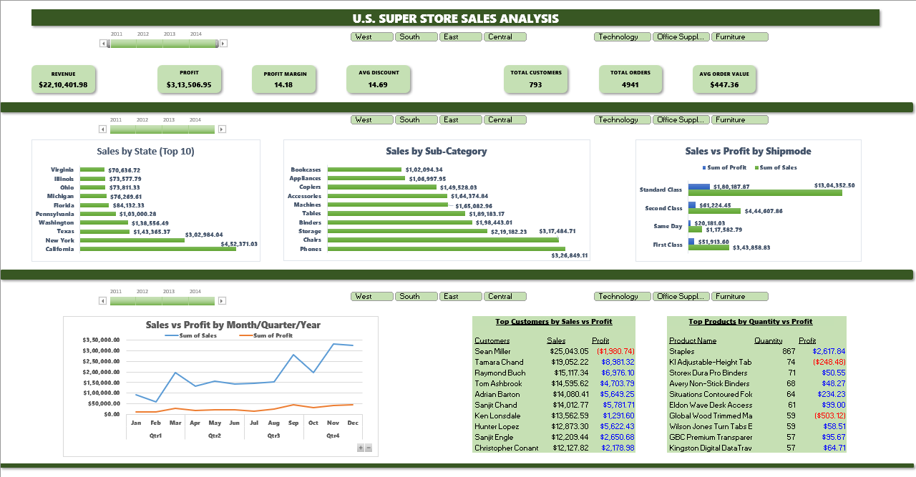

# Conclusion:

The **Final Dashboard** helps us to discover the **Trends** and **Patterns** underlying in the **Data** to take the necessary decisions in the **Business**.

**KEY FINDINGS:**

1. **Year 2014** has the highest **Revenue** of **$7,13,615.71**, compared to other **three years**.
2. **West Region** has generated the highest **Revenue** of **$7,14,625.79**, compared to **other regions**.
3. **Technology Category** of the **Product** has generated the highest **Revenue** of **$8,05,834.93**, compared to **other product categories**.

Therefore coming to the Product Sales and Customer Behaviour, we should concentrate more on the West **Region** and on **Technology** categorized products.

**—----------------------------------------------------------------------------------------------------------------------------**

**Thank You**

**Srikrishnan S**

**Email_Id: srikrishnan214@gmail.com**